**Docker Installation**

**Prerequisite:**

🡪OS Must be Windows 10

🡪Hyper V Must be Installed

🡪Install wsl Setup from \\chpnxfsvr\qa\PhoenixTest\Drivers\wsl_update_x64.msi

**Docker Installation:**

Download Docker Desktop from the Following Link <https://desktop.docker.com/win/main/amd64/Docker%20Desktop%20Installer.exe?utm_source=docker&amp;utm_medium=webreferral&amp;utm_campaign=dd-smartbutton&amp;utm_location=module>

Once After Downloading Docker Double click the Docker Executable file to install docker

Click Ok

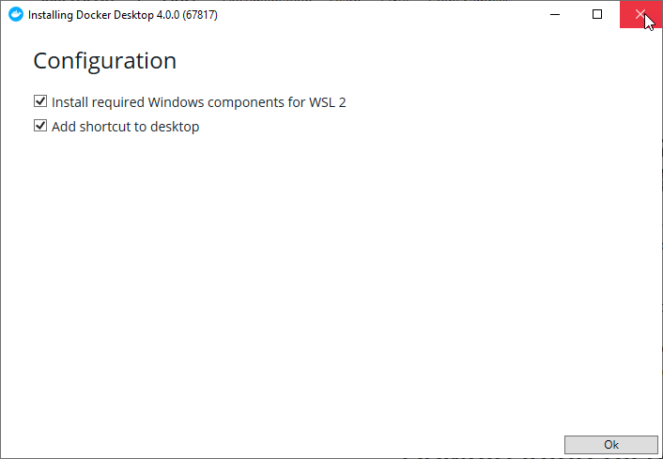

After Clicking ok it will take some time to download the package

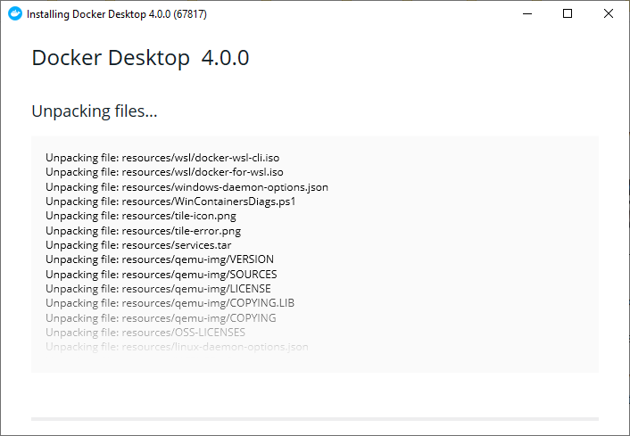

Once After Installed it will Show Installed Successfully click close

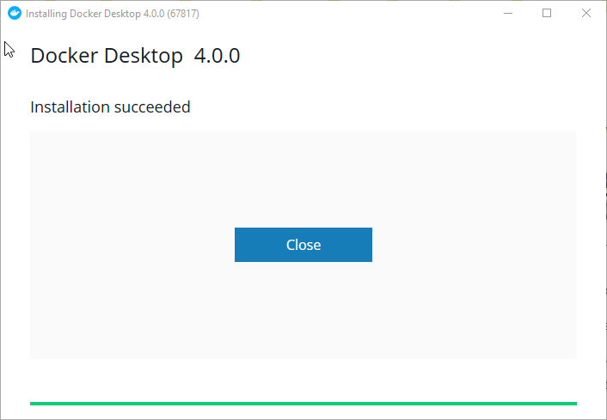

Open the Installed Docker Desktop App from the Start

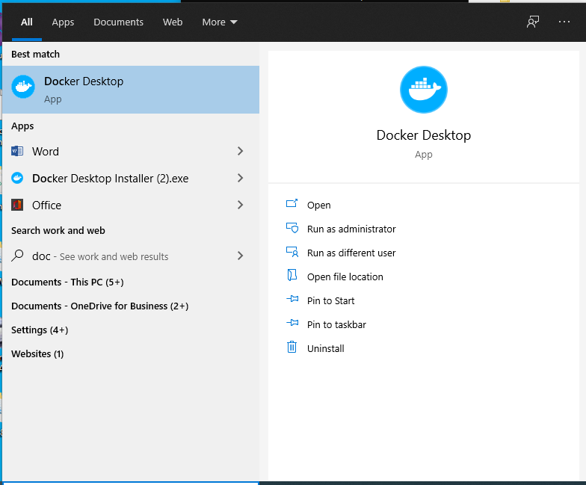

Once After Docker Opens Agreement Screen opens click accept checkbox and click accept



Once After Clicking Accept expand the icon in the Taskbar wail for Docker Icon to become Stable

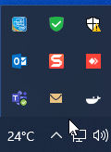

Once After Docker Icon Stable the following Screen Opens click Skip Tutorial

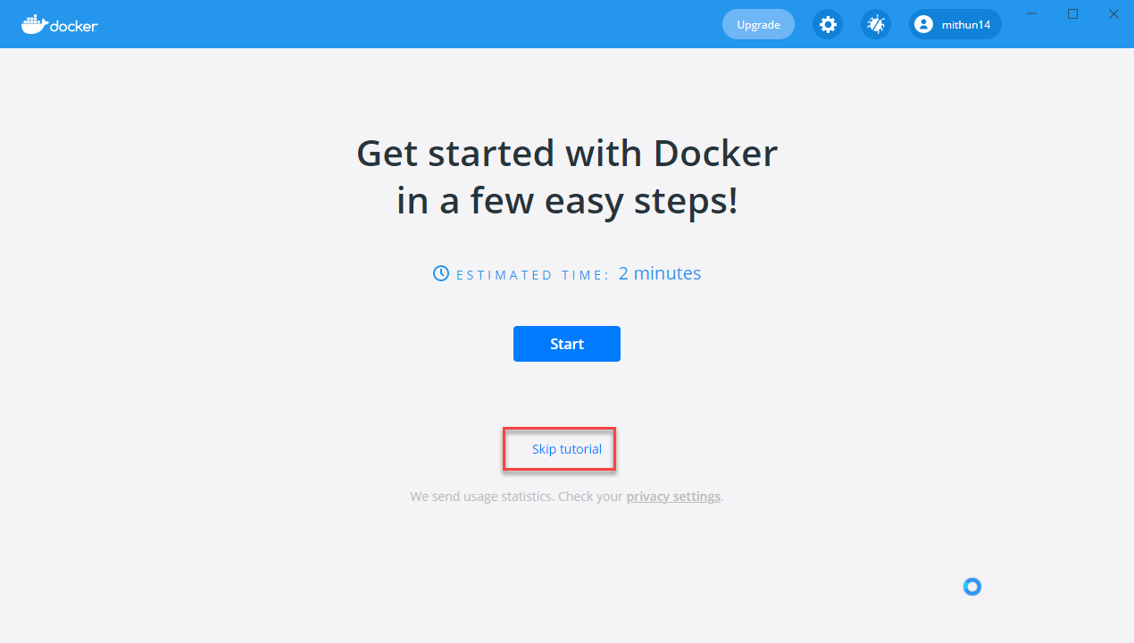

Initially the images and Container/Apps will be empty once after installing images and running containers it will displayed

